7/4/2022 1:02:55 AM

NAME: Sumayya Nura | Age:Ad | Sex:F | Ref No:00010
Clinical Details: USG Pelvic |  |  |  | US:

REAL TIME PELVIC ULTRASONOGRAPHY EXAM: REVEALED:

URINARY BLADDER: Distended with urine with Normal mucosal wall thickness. No gross masses or stone seen.

UTERUS: Anteverted and empty. Normal in size and contour. No evidence of pregnancy or
retained product of conception. Myometrial and central endometrial echoes are preserved. Right and Left adnexia are free.

CUL-DE-SAC:There is free fluid collection in the pouch of Douglas.
All other abdominal organs are within normal limits

IMPRESSION: Features are suggestive of PID
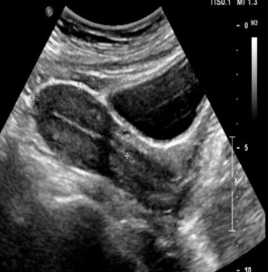
Ultrasound Specialist.

